**PROJECT-1**

Name-H. Sanyam Kumar

Phone No.-6370020990

**Process flow:**

**How to load the csv file (or other extension file):**

1. Open Power BI, after that an interface will come. Select the “Blank report” option from the other options. (as shown in picture)

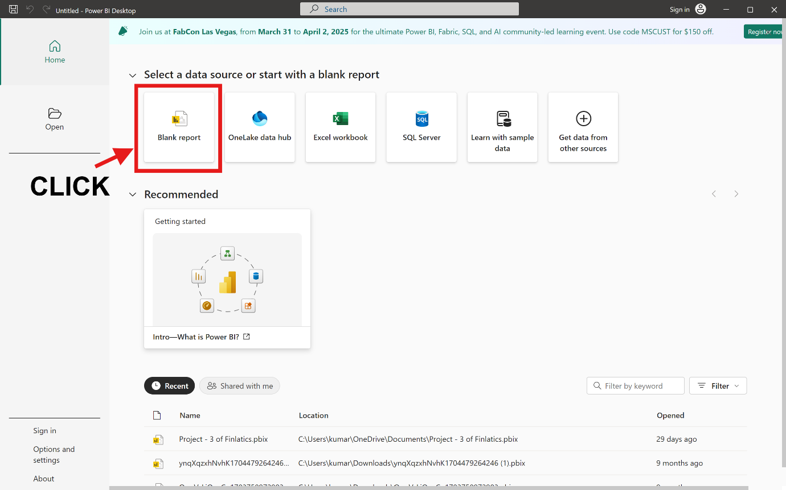

1. Click on the “Get data” option on the top dashboard canvas.

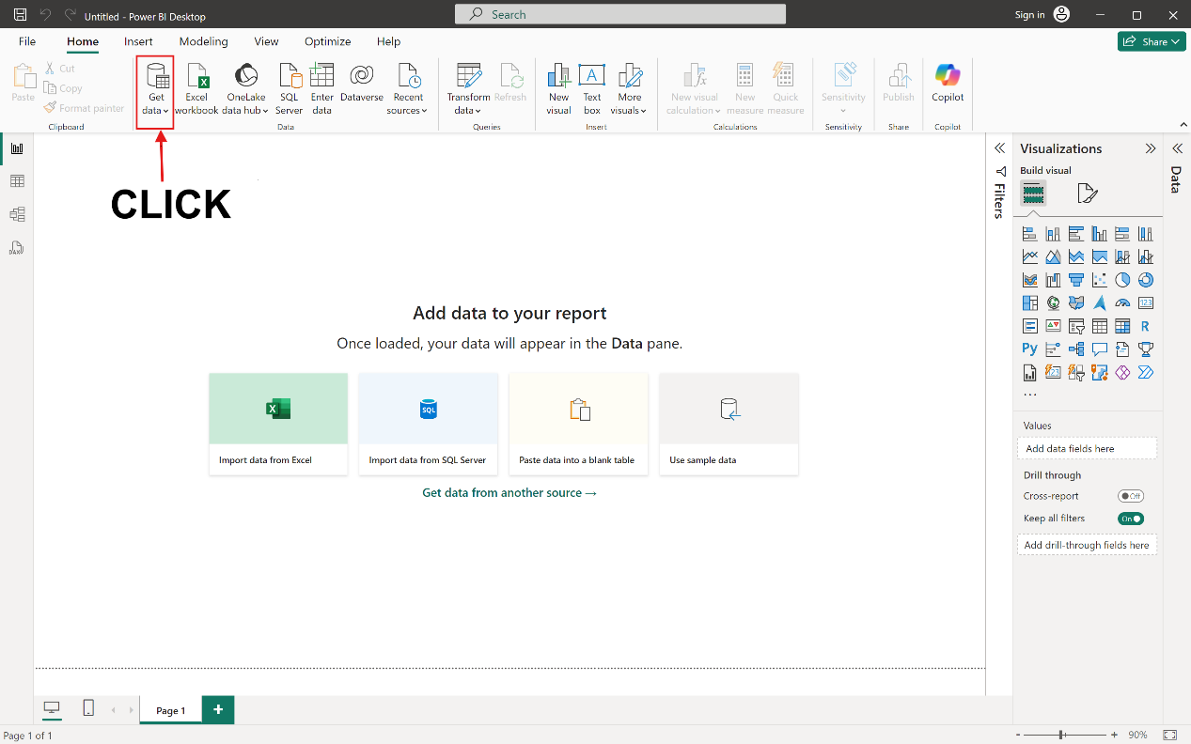

1. Then, It will show some options. Select the “Text/CSV” option.

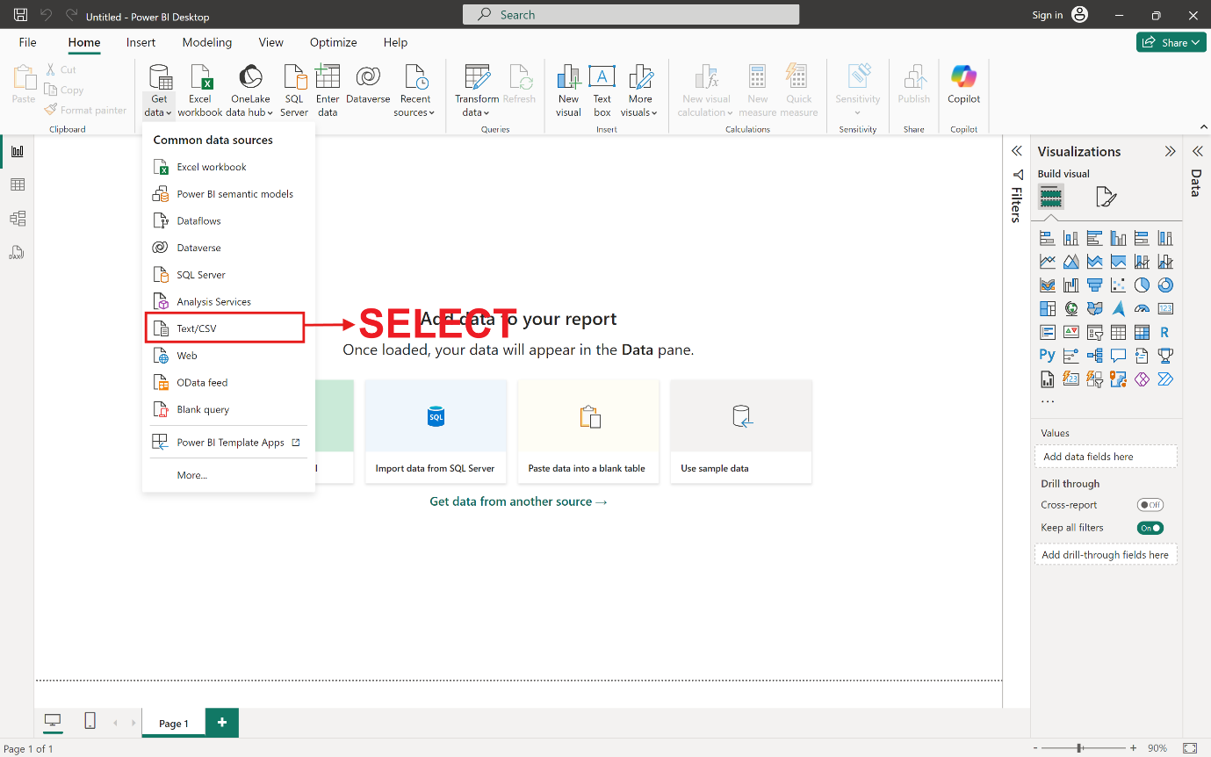

1. After that it will show your local file which are available in your system. Select the file (CSV File) which you want to open and click on “Open” button.

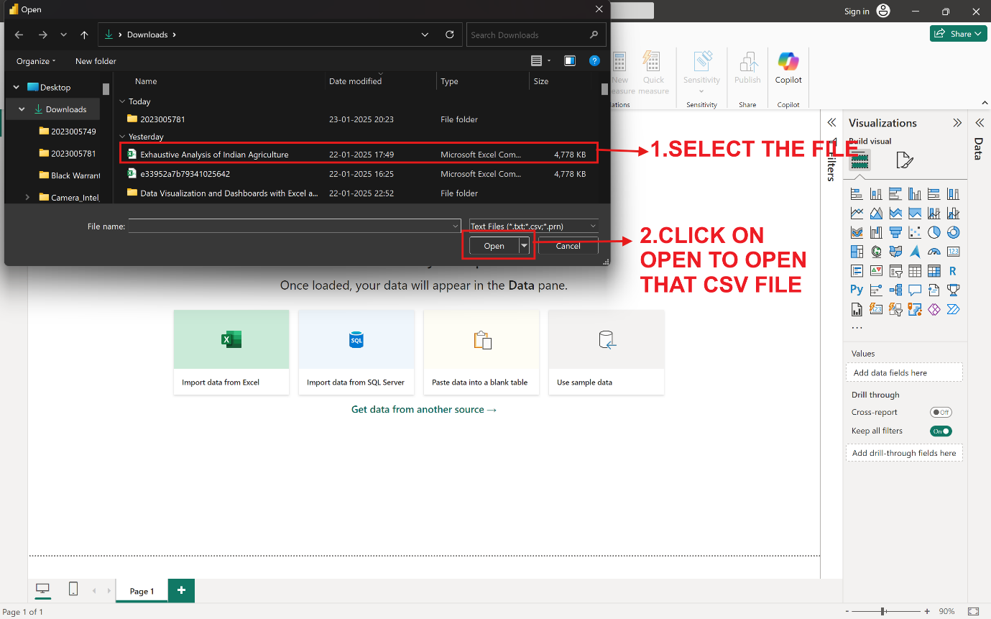

1. It will take some time to load. Then, one interface(data will shown in table) will come. After that click on “Load” option if your dataset (CSV file) is clear and have no error. After that it will Load the CSV file.

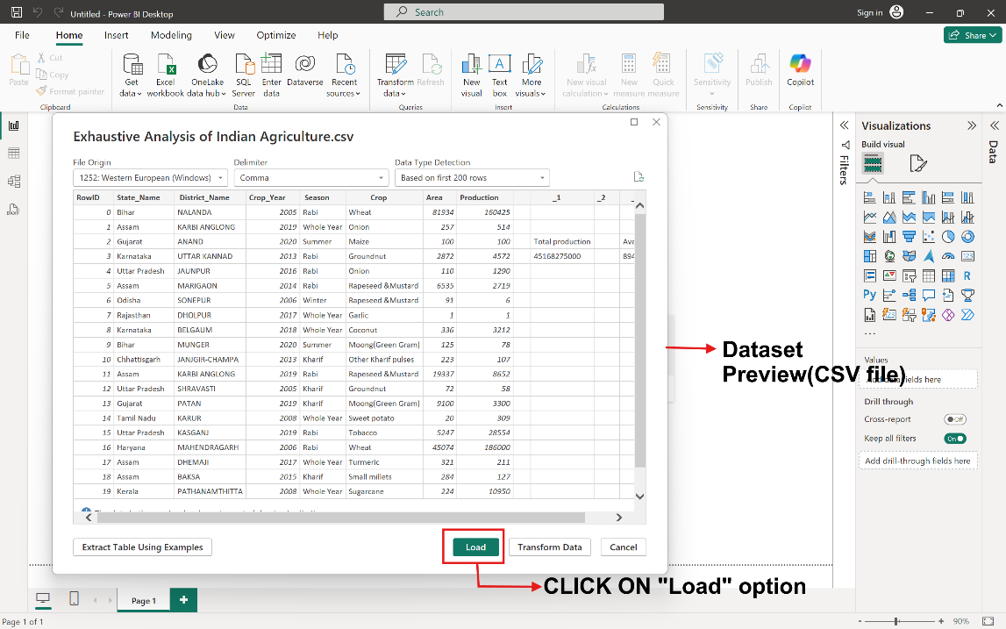

1. After load, It (CSV file) will appear in “Data” tab which is located right of the dashboard canvas. (as shown in the figure)

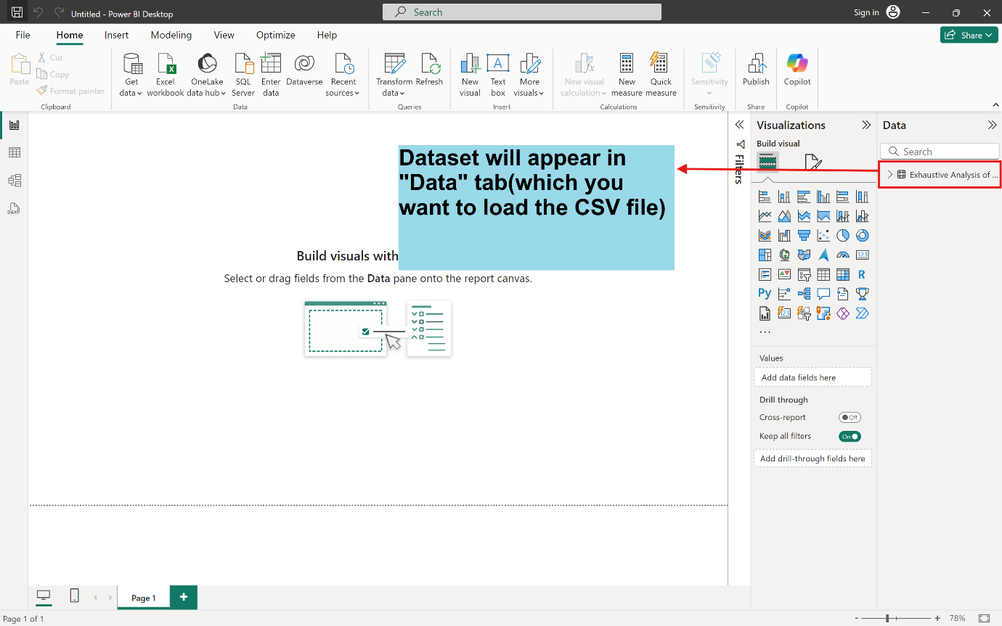

**How to Transform Data and Delete columns in the data set:**

1. Click on the “Transform data” tab which is present top of the dashboard canvas.

If your data is not clean, then you can proceed to it.

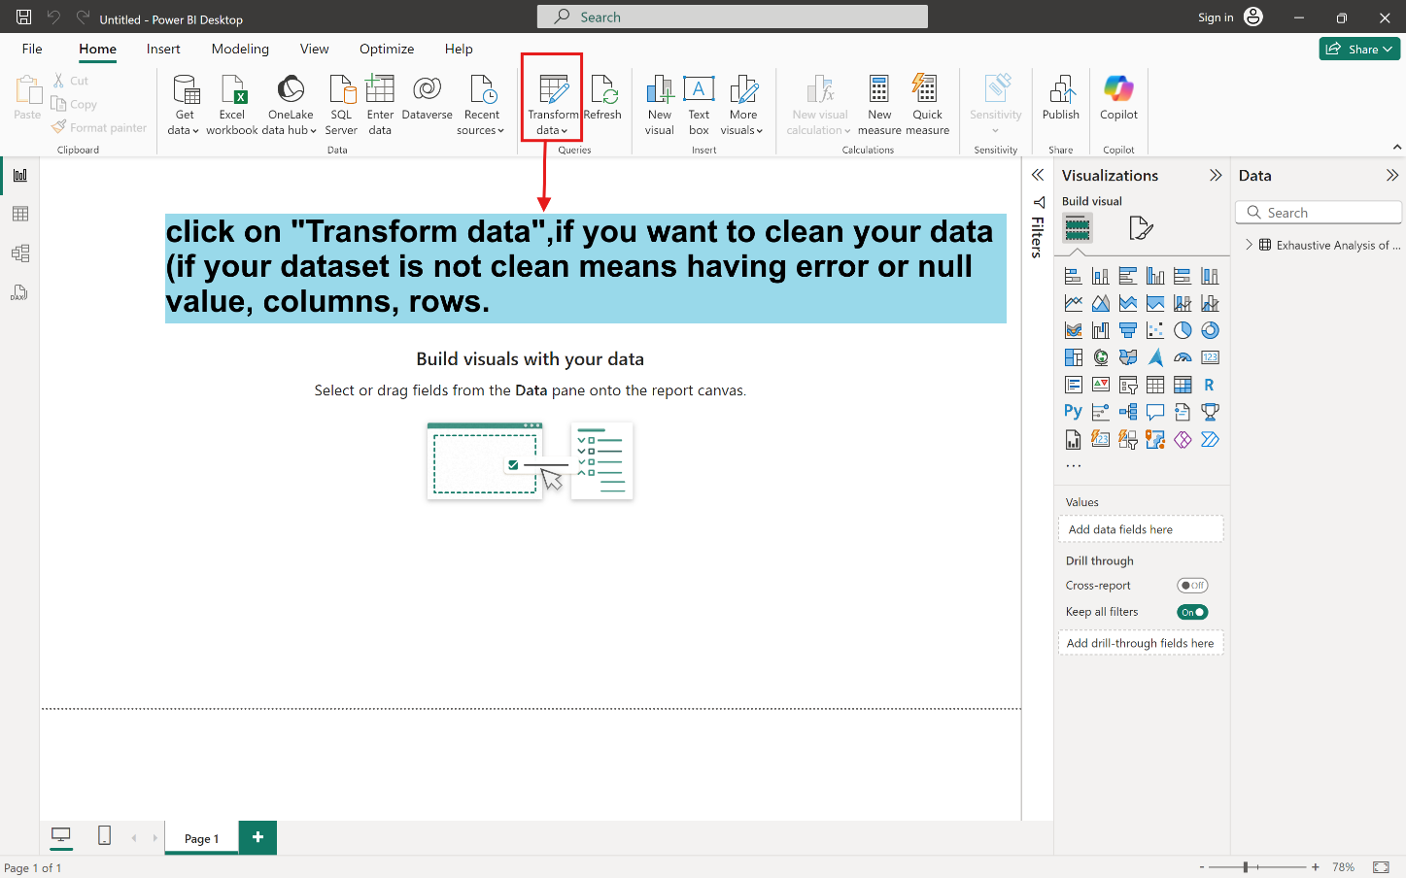

2. After clicking the Transform data, It will appear like presented (as in picture) below.

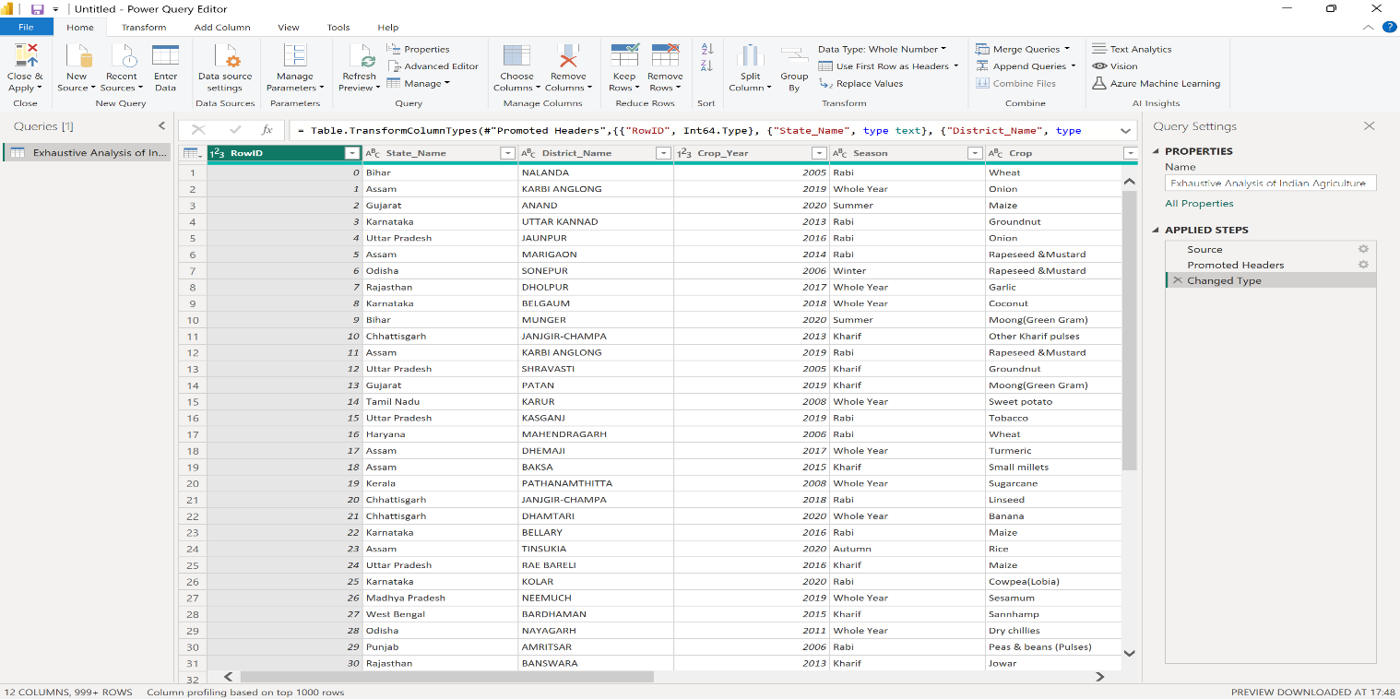

3. If you want to delete the column, then select the column which want to delete

and right click on it after that “Remove” option will appear, click on it. (It best for single column or less columns but not for multiple columns.)

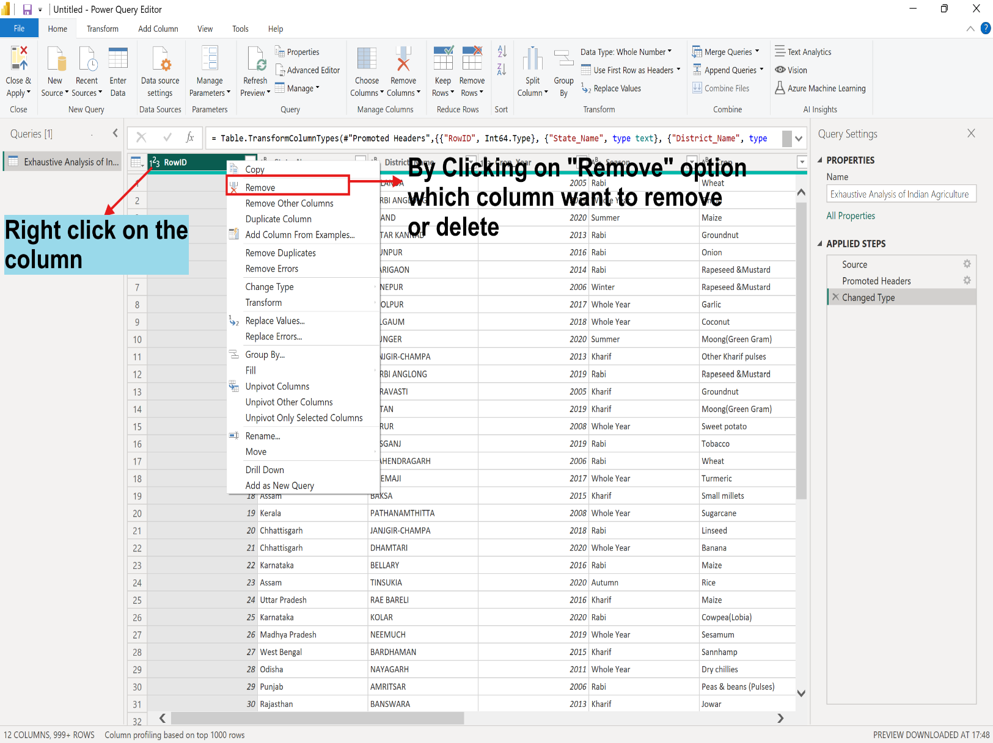

**(OR)**

3. 1. For multiple Columns, If you want to delete all the columns at time. You can see in the top of Dashboard canvas in Home tab, select “Choose Columns” option in Manage Columns.

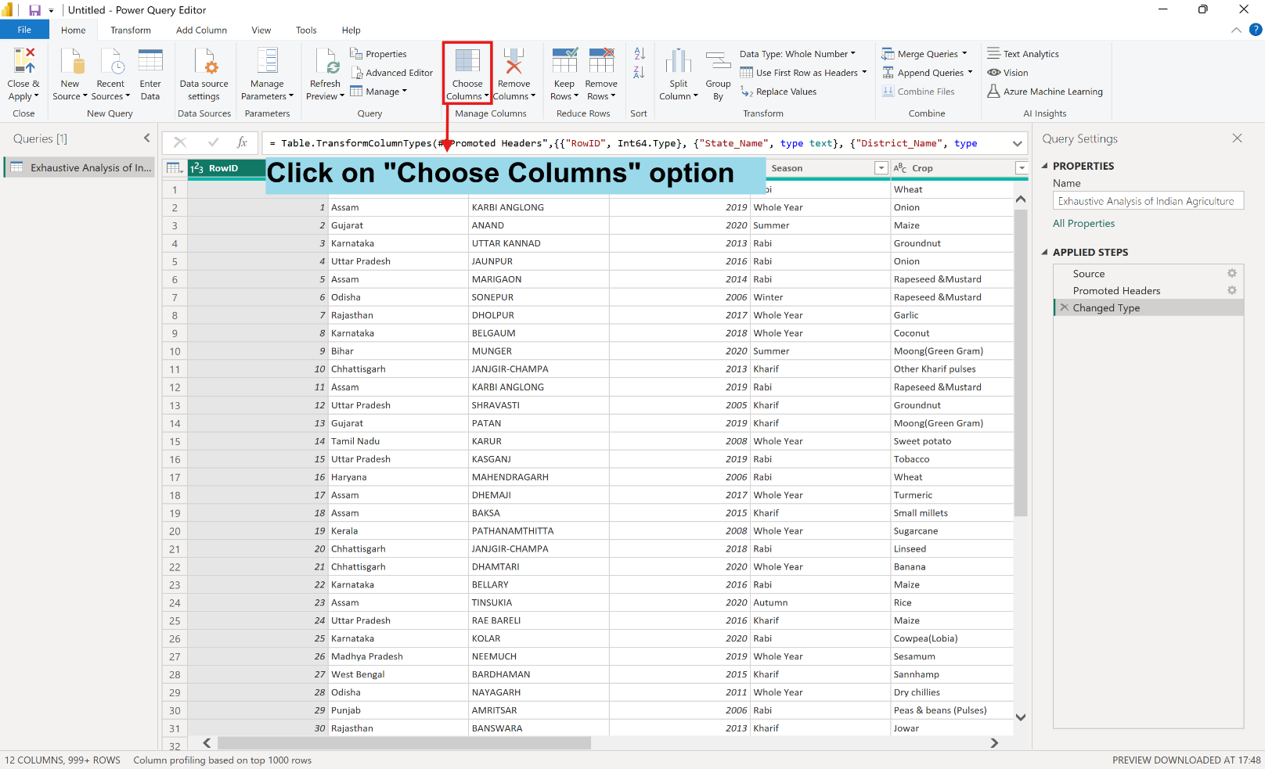

3. 2. Then, unselect all the columns and only select the columns which you want to delete or remove and also click on “OK” button below it. It will appear.

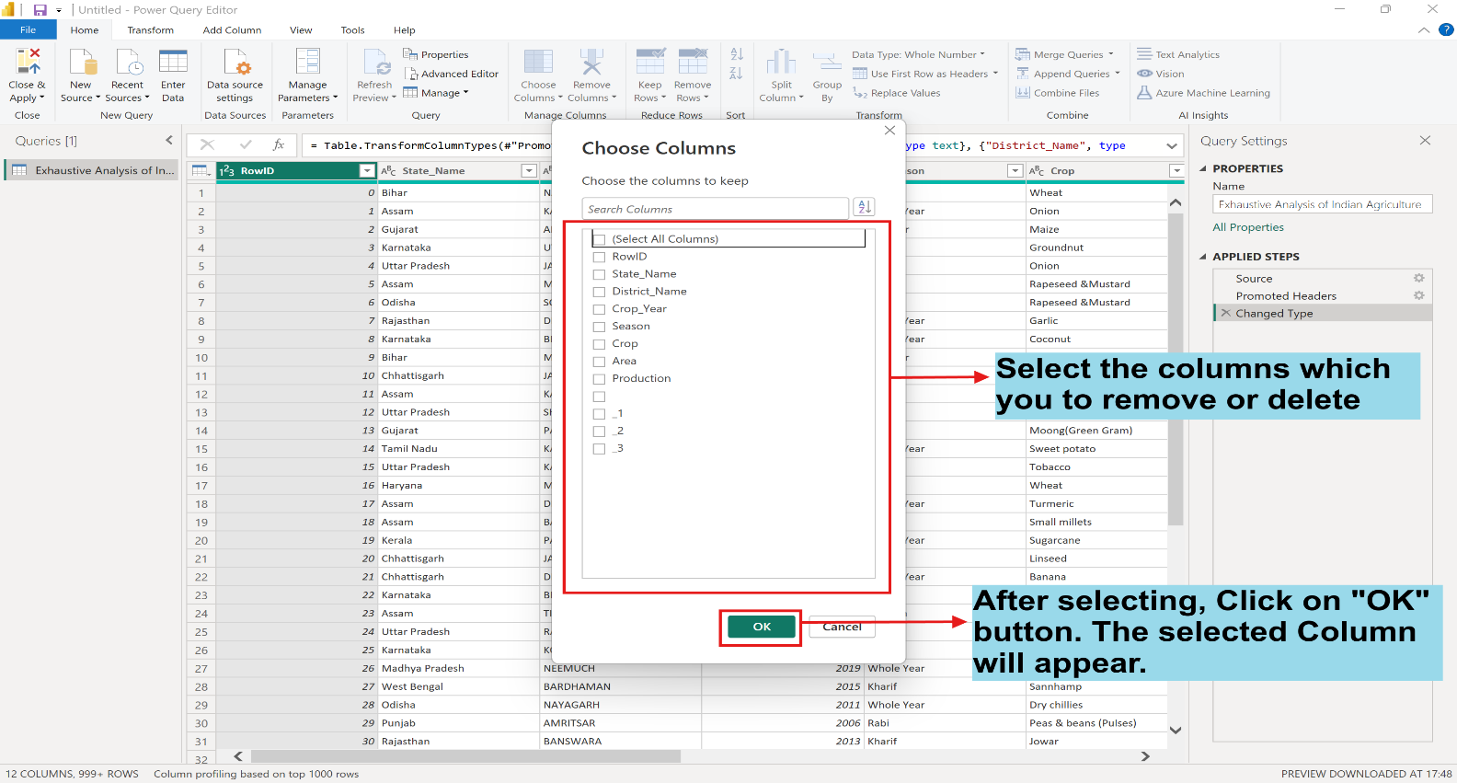

1. 3. Select all the columns and click on the “Remove Columns” in the Manage Columns tab. After that click on cross button of removed other columns in “Applied Steps” tab and click on delete button. It will show other remaining columns.

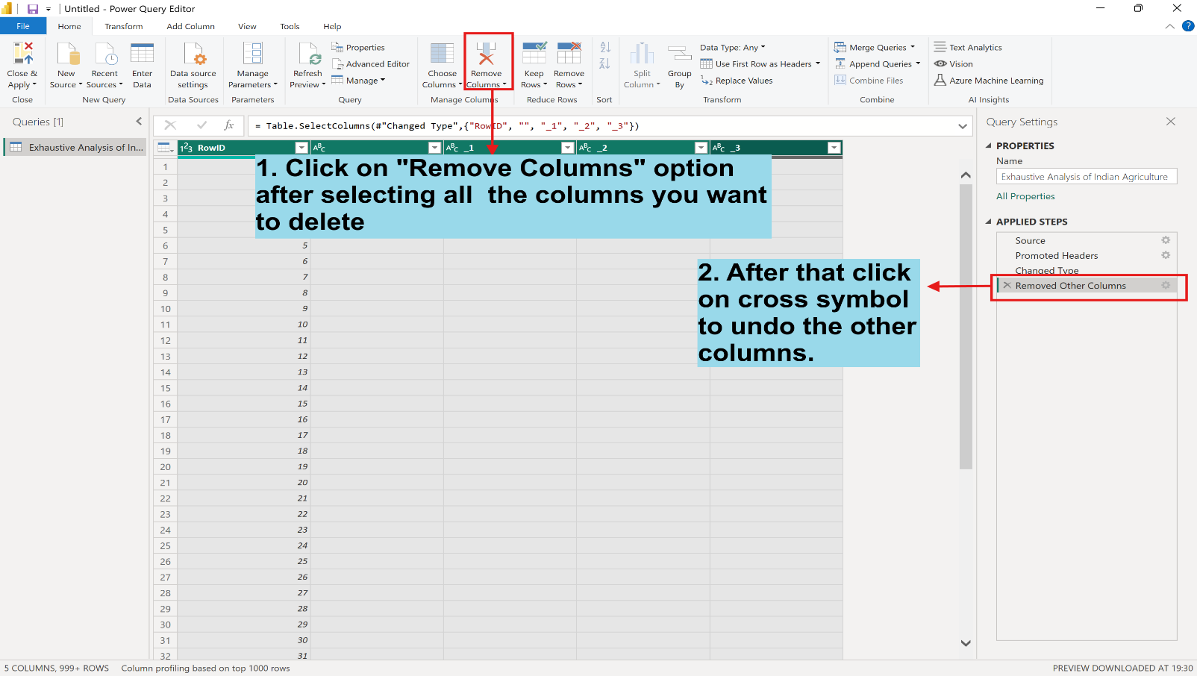

**How to check if there’s empty and null value or not and also close and apply the changes:**

1. Click on View tab, then click on “Column quality” option. It will show some results (as shown in picture).

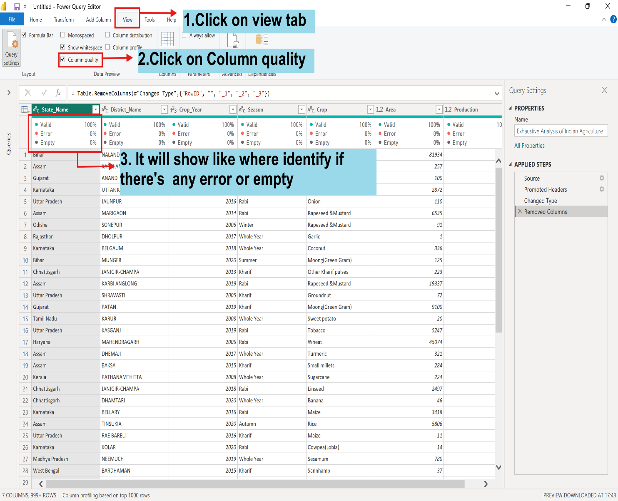

1. If you want to apply all change you have done. Then go to “Home” tab and click on “Close & Apply” button.

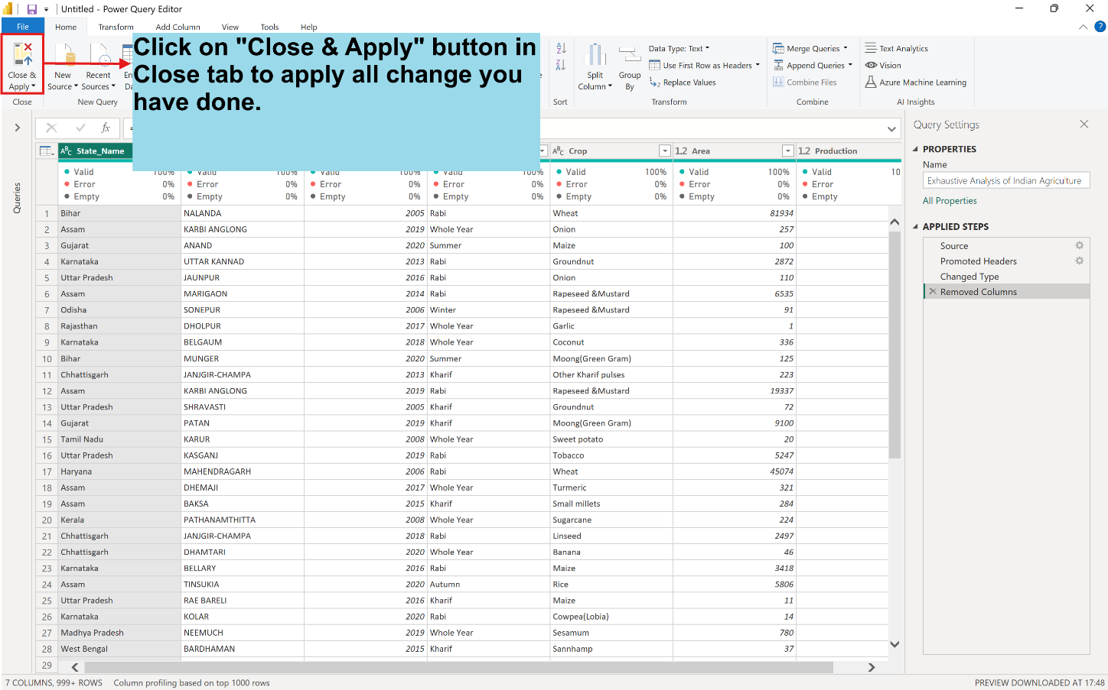

**The Final Dataset will look like this (in “Table view”):-**

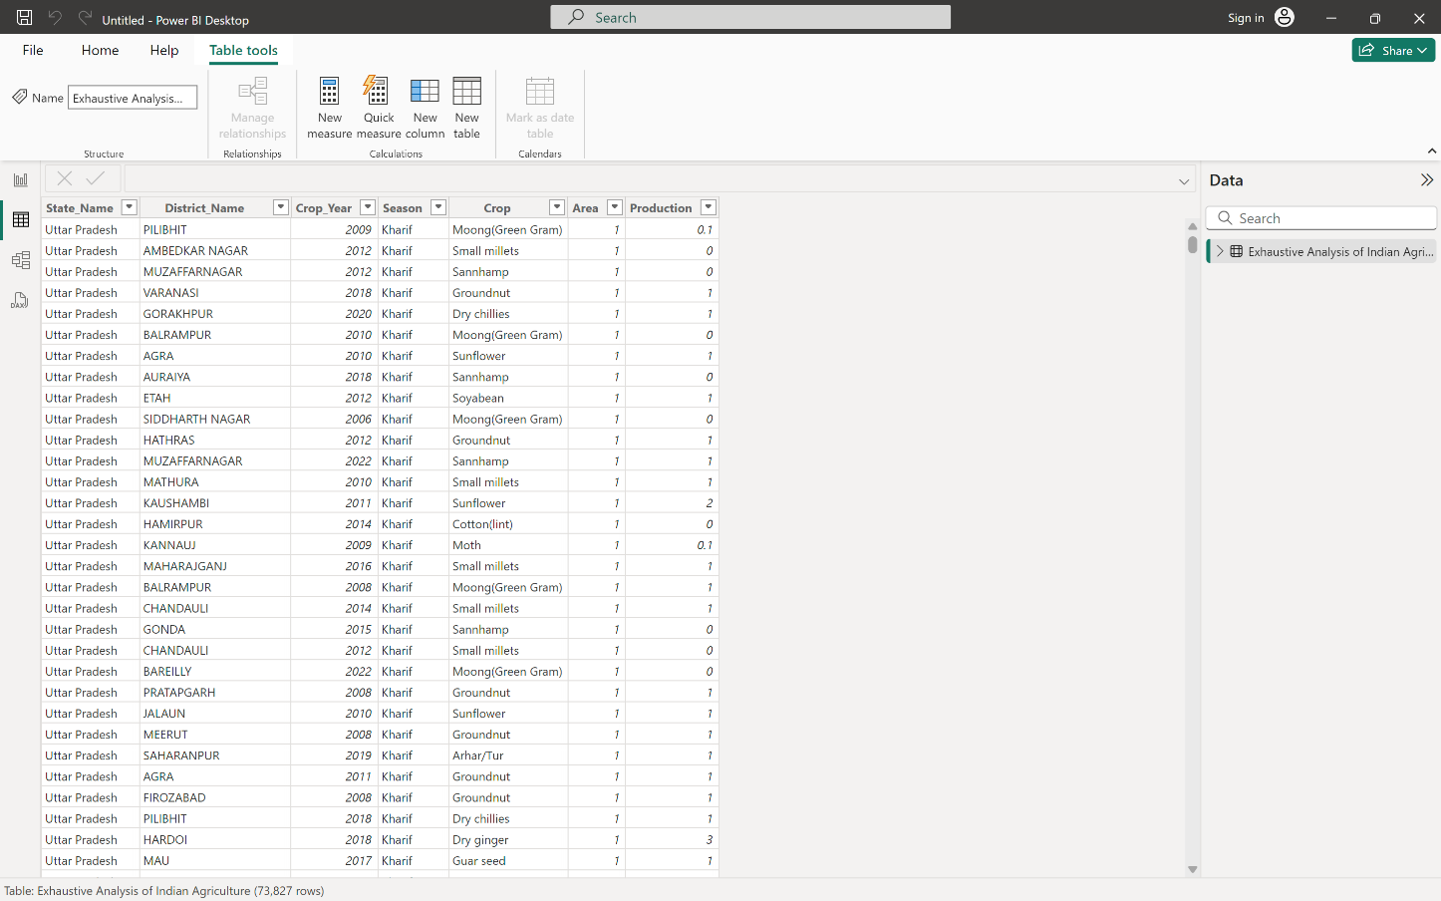

**NOTE:-**

**Report View:** Visualization (create).

**Table View:** To see the data in table format.

**Model View:** To create relationship among data.

